
СЕРІКҚЫЗЫ Айгерім,
№4 Балжан Бөлтірікова атындағы мектеп-лицейінің ағылшын тілі пәні мұғалімі.
Жамбыл облысы, Қордай ауданы

ANALYZING THE SPECIFIC FEATURES OF ANIMALS

Learning objectives | 11.3.5 - interact with peers to make hypotheses and evaluate alternative proposals on a range of familiar and some unfamiliar general and curricular topics;  11.5.1 - plan, write, edit and proofread work at text level independently on a wide range of general and curricular topics;  11.5.4 - use style and register to achieve an appropriate degree of formality in a wide variety of written genres on general and curricular topics.
Lesson objectives  (assessment criteria) | Learners will be able to:  - Identify specific features of different animals, dividing them into groups by types  - Understand animals’ habitats and basic needs  - Demonstrate understanding through listening, labeling activities or matching features to animals.  - Develop respect and empathy for wildlife (жануарлар әлеміне деген құрмет пен эмпатияны дамыту)
Instilling values of the program “Adal Azamat” | - «Тәуелсіздік және отаншылдық» — Independence and patriotism

Stages/  Time | Teachers actions | Students actions | Assessment | Resources
Beginning  2 min  5 min  5 min | Organization moment  1.Greeting.  - Hello class!  - “How are you today?” (Students reply: “I’m fine, thank you!” or other feelings.)  - “What day is it today?” (Students respond: “It’s Friday!”)  - “What’s the weather like today?” (Students answer: “It’s sunny!”)  2. Warm up: “Guess the animal”. Purpose: Vocabulary, quick thinking. How to play:  3 Checking the previous lesson:  Wordwall task:  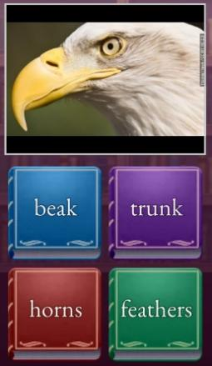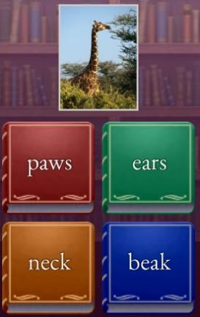 | Ss greet their teacher and answer the questions  Students choose a card and describe it, others find the animal  Learners name the parts of animals’ bodies | Teacher evaluate pupils with phrases like:  “Good job!  Well done!”  Formative Assessment   | Slide 1  Slide 2  Wordwall
Middle  8 min  7 min | Pre-reading :  Show pictures of animals’ types (e.g. reptiles, fish, mammals).  Ask: - "What do you see?  - What types of animals do you know?"  Theme Presentation  Present some specific features of animals, grouped by type  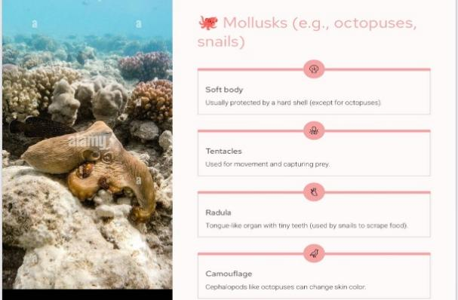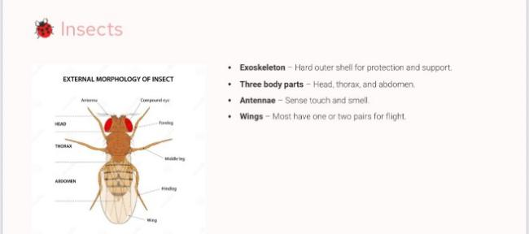  While reading (W)  Fill in the blanks | Learners look at the pictures and share their ideas  Ss learn new theme  Learners read the given pictures on the board and name the groups of animals  Ss listen to the text and answer the questions  Students divide animals into their groups, matching the pictures to appropriate column | Descriptor:  - describe a wide variety of specific features  -answer simple questions and give personal examples.  FA : 3 p  Excellent (2)  - Frequently uses vocabulary and expressions from the lesson accurately.  Good (1)  - Sometimes uses lesson vocabulary, with occasional errors. | Flashcards  Slide 4  Poster
  MAMMALS
  WILD MAMMALS | DOMESTICATED | SMALL | MARINE | UNIQUE
  REPTILES
  LIZARD | SNAKES | TURTLES&TORTOISES | CROCODILIANS
5 min | Listening task  Ex 1: Listening Comprehension Questions | Learners watch a video and identify the right answers  ANSWERS :  1 c  2 c  3 c  4 c | Descriptor:  - read the text quietly on their own.  - find the correct answer  FA : 3 p | Video  Kahoot
7 min | Ex: 2 Group work  Create your own animal  -Ask students to make a poster showing their own animal  * Animal’s name  * Where does it live?  * What does it eat?  * Features (wings? fur? cold-blooded?)  * Draw it! | Learners describe their habitat and specific features  Values of the program “Adal Azamat”  –Showing respect for work and working together in a group | Descriptor:  - use new words  - describe clearly  - pronunciation is excellent, good  FA : 3 p
3 min | Reflection    Assessment Map | Learners complete the traffic light and write what they understood on the lesson. | 9-10points – “5”  7-8points – “4”  5-6points – “3” | Traffic light cards
End  3 min | Homework: Write a short description of animals.”  Saying good-bye | Ss use their stickers to show their knowledge according to the lesson

